MSIS 638

Jia Liang Ma

Case 3.3a

1. Search for the location of distribution centers (DCs) and stores of a retail store (e.g., Target, Walmart, and Staples) in a specific area (e.g., in a state).

Marshalls DC (MA), location: 83 Commerce Way, Woburn (1)

Rotmans DC (MA), location; 100 Adams Rd #4, Clinton (2)

Target, location: 7 Allstate Rd. Dorchester (MA)

Walmart, location: 250 Hartford Ave, Bellingham (MA)

1. Develop a transportation problem for distributing an arbitrary item from the DCs to the stores. You can use made-up numbers for the demand at each store and inventory availability at each DC.

Hint: You need to think about what objective function to choose. For example, should it be based on travel time or distance

For supply and demand, Target has 500 supply and Walmart has 700 supply. Marshalls DC has 550 demand, Rotmans DC has 650 demand.

We assume the transportation fee of Target is $20 per time, and the one of Walmart is $15 per time.

For the distribution distance and charge per time, Walmart has $7 to Marshalls and $4 to Rotmans; Target has $6 to Marshalls and $8 to Rotmans.

1. Write the complete formulation. (Walmart for W, and Target for T)

All variables ≥ 0

Xij: From Store(i) transport to DC(j)

Xij ≥ 0

Object function: Min 22Xw1 + 19Xw2 + 26Xt1 + 28Xt2

Decision variables:

Constraints:

Xwm + Xwr ≤ 700 (Supply)

Xtm + Xtr ≤ 500 (Supply)

Xwm + Xtm = 550 (Demand)

Xwr +Xtr = 650 (Demand)

1. Use Excel to solve the formulated problem. Remember to generate and Answer and Sensitivity reports.

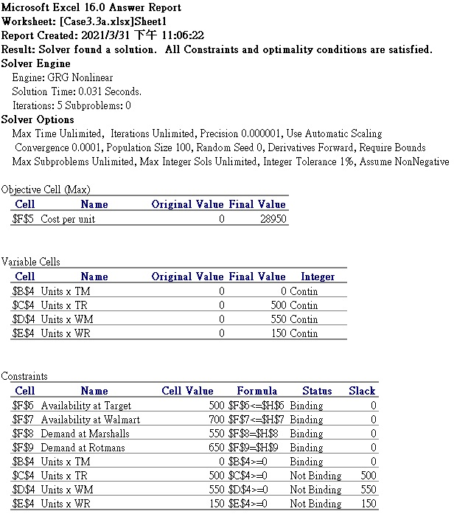

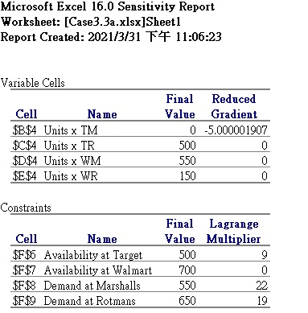

1. Use the Sensitivity report to answer the following questions:
   * If they have some extra inventory, at which DC should they store them?

As the sensitivity report shows, they can store the additional inventory in Marshalls.

* + If they can manipulate the demand at stores through increasing the price, which store(s) should be given priority for reducing demand?

According to the report, Target to Marshalls has the reduced gradient. Also, the price in Walmart is cheaper. In this way, Target should be given priority for reducing demand.